Table of Contents

Introduction 1

Object Relational Mapping (ORM) 2

Django Models 2

Migrations 3

DB Browser for SQLite 4

Inserting Data into the Database with SQL 4

Saving Changes to the Database 5

Querying from a Shell Application 6

Starting the Shell 6

Exiting the Shell 7

Getting All Rows of a Table with the ORM 7

Querying a Single Object with the ORM 8

Filtering Multiple Items with the ORM 8

Deleting Objects with the ORM 8

Creating Objects with the ORM 9

Updating Objects with the ORM 9

Joins 10

Accessing Database Content in the Application 12

Using the Admin Panel 15

Viewing Users From the Admin Panel 16

Viewing Database Content from the Admin Panel 17

## Introduction

The goal of working with Django is to demonstrate a way to connect predictive model development with application development. Last week, content covered a very basic model deployment to an application in production.

For application development flexibility, this document explains how to take advantage of the database connectivity and database mapping features that are built-in to Django.

For ease of deployment and learning I have decided to use Sqlite database. I am guessing you may have used Sqlite database by now. Sqlite is especially popular in Android and iOS applications since it manages data for single user applications while enabling relational structure and standard SQL queries that are similar to much larger relational databases. Most applications that are built with SQLite can easily be converted to standard multi-user databases. I often use SQLite when developing cloud based applications so I can avoid wasting money or credits on database servers. When the application is ready to go live switching from SQLite to a multi-user application is easy. A team of two to three developers can access an application which uses SQLite without issue.

This tutorial is excellent and I have based several sections of this document on the content presented at this site.

<https://www.techwithtim.net/tutorials/django/sqlite3-database/>

## Object Relational Mapping (ORM)

Most web frameworks and code frameworks enable object relational mapping (ORM). ORM systems allow applications to communicate with databases through an object-oriented interface. .NET, Node, Laravel, Ruby and so many other main stream frameworks use ORM code as one of the most popular methods for communicating with relational databases.

## Django Models

Models are classes in an ORM which define the attributes of a database table. These classes also allow object-creation in code for object-oriented management of the data.

Example 1: Creating a Model in Django

For this tutorial we will be creating a basic to-do list. This means we will need a model for a to-do list and for each of the items on our to-do list.

This example shows how to create a model in Django, and how to use it to create a table in the database. As mentioned earlier, SQLite will be used for the Django application. The Django application already references the SQLite database by default.

Starting with the local working application from last week’s lesson (week 8), navigate to **models.py**from inside the application (pages) folder.

When defining the model, create a class that is the name of the model. The model must inherit from **models.Model**. Then define all of the fields or attributes of the model as class variables. Methods can also be added to the models. This code creates the two models:

|  |
| --- |
| from django.db import models  # Create your models here.  class ToDoList(models.Model):  name = models.CharField(max_length=200)  def __str__(self):  return self.name  class Item(models.Model):  todolist = models.ForeignKey(ToDoList, on_delete=models.CASCADE)  text = models.CharField(max_length=300)  complete = models.BooleanField()  def __str__(self):  return self.text |

## Migrations

Migrations implement model structure changes to the database. To do this, run the following command in the PyCharm terminal:

python manage.py makemigrations pages.

**Note:** If your app is named something else replace "pages" with its name.

When running the *makemigrations* command the following output should appear:

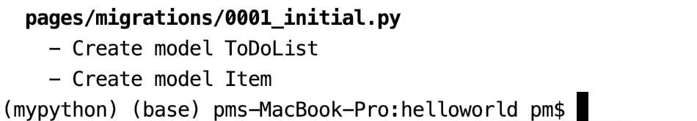

Making the migration generates code that is needed to create the corresponding database table.

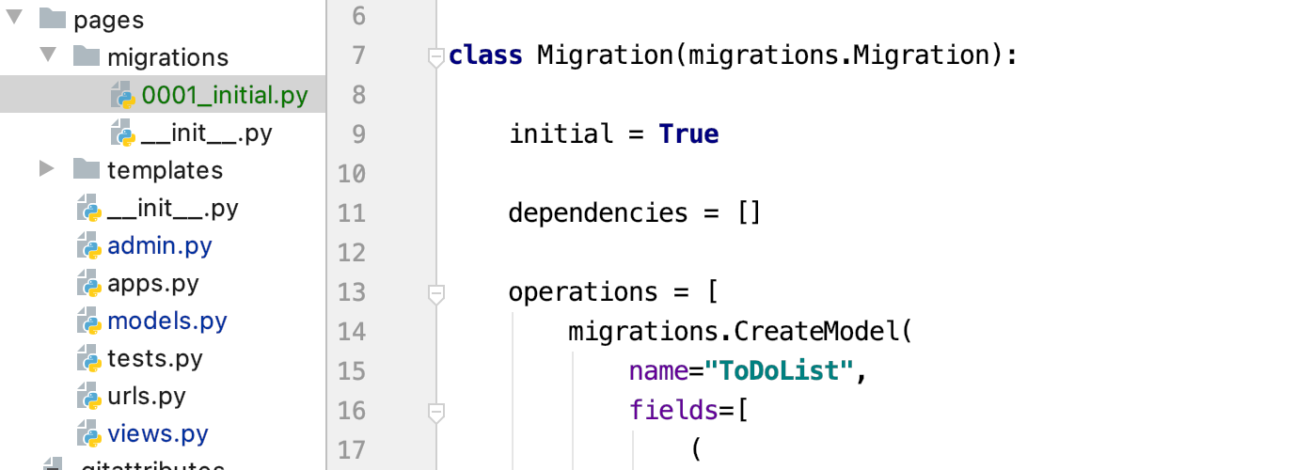

After the migration code has been generated, to apply the changes to the database run the following command:

python manage.py migrate

The following output will appear when performing the migration:

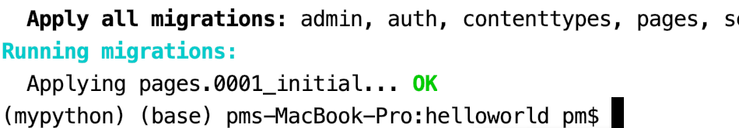

## DB Browser for SQLite

DB Browser for SQLite is an excellent tool and it will allow you to view the local SQLite structure and to run queries against it. It can be downloaded from <https://sqlitebrowser.org/>

## Inserting Data into the Database with SQL

Example 2: Inserting Data into the Database

This section shows how to insert data into the pages_todolist table and the pages_item table. To open the SQLLite database file, navigate to it from the **File** menu of DB Browser for SQLite or drag the file onto DB Browser for SQL lite. The file should be visible from the pages directory.

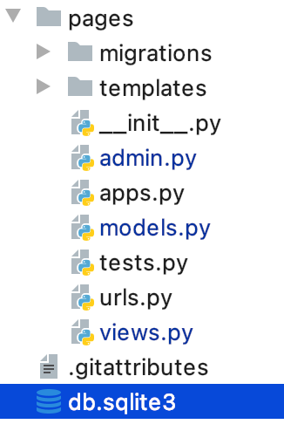

Next, execute the following INSERT statements to insert data into the pages_todolist table:

|  |
| --- |
| /* Insert data */  INSERT INTO pages_todolist VALUES(1, "Errands")  INSERT INTO pages_todolist VALUES(2, "BCIT work") |

The statements can be run from the Execute SQL tab of DB Browser for SQLite.



After executing the INSERT statements, it is possible to view the data in the table by choosing **pages_todolist** in the dropdown of the Browse Data tab.



Next, to insert data into the pages_item table, run these instructions from the Execute SQL tab of DB Browser for SQLite.

|  |
| --- |
| INSERT INTO pages_item VALUES(1, "Buy grapefruit.", 0, 1);  INSERT INTO pages_item VALUES(2, "Do laundry.", 0, 1);  INSERT INTO pages_item VALUES(3, "Study for COMP 4949", 1, 2);  INSERT INTO pages_item VALUES(4, "Study for COMP 4948", 1, 2); |

Exercise 1 (2 marks)

Then in the editor, add an insert statement to insert a value into the first errands list which says “Make sure **<your name>** gets rest”.



Show a screenshot of the data in DB Browser for Sqlite with your name in it here:

|  |
| --- |
|  |

Show the SQL statement used.

|  |
| --- |
| INSERT INTO pages_item VALUES(5, "Make sure Victor gets rest.", 0, 1); |

## Saving Changes to the Database

Note when you use DB Browser for SQLite, the data is not committed to the database. To ensure it is saved when the database is closed, it is necessary to write the changes as demonstrated in the screenshot below.



To release the database so other applications can use it, click Close Database after saving the changes.



When prompted to save changes choose yes.



I am probably taking too many steps but to avoid issues with saving content. However, I recommend double checking to ensure the database contents are saved and to ensure that the file is not locked by closing DB Browser for SQLite.

## Querying from a Shell Application

For learning purposes, without requiring additional Django code to render content, this section will explore querying the database using a shell application from the console. The query commands used in this section can later be used in your Django code as well.

### Starting the Shell

Example 3: Launching a Shell Program

This example shows how to start the shell application. To activate the shell, run the following command in the PyCharm terminal.

On Mac

source mypython/bin/activate

On Windows (this is the path the Activate.ps1)

mypython\Scripts\Activate

When the prompt is running from the same directory as **manage.py**, then launch the shell with the command:

**python manage.py shell**

This is the output that appeared when I switched to the virtual environment and launched the shell.



### Exiting the Shell

To exit the shell run:

**quit()**

### Getting All Rows of a Table with the ORM

Example 4: Getting All Rows of a Table

This example shows how to retrieve all rows of a table. Use the following instructions to reference the models of the application:

|  |
| --- |
| from pages.models import Item, ToDoList  t = ToDoList.objects  t.all() |

When you run the application at this point you will see the following output:

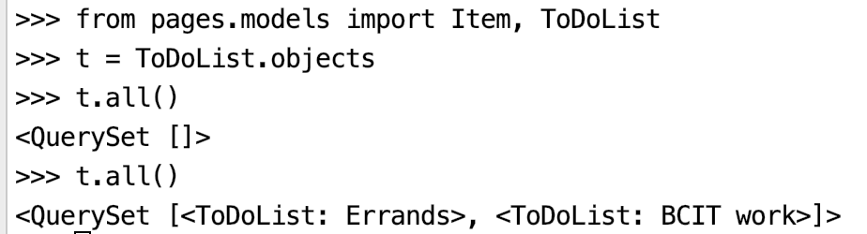

Exercise 2 (3 marks)

Show a screenshot of the shell which displays all of your data from the Item table. The output must include the row of data that includes your name. The output should show your name and look something like this:



Show your screenshot here:

|  |
| --- |
|  |

### Querying a Single Object with the ORM

Example 5: Querying a Single Item

This example shows how to retrieve a single object based on an attribute value. For this example, the first item of the pages_todolist table is selected:

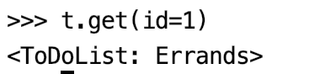

Exercise 3 (2 marks)

Show the query needed to retrieve only the item that contains your name in it from the errands list. Show a screenshot of the shell console with the query and your name in the output.

|  |
| --- |
|  |

### Filtering Multiple Items with the ORM

When retrieving more than one row, it is possible to implement many other filters. Here are some examples of filters.

**Note:** Notice that double underscores and attribute names such as ‘**headline**’ and ‘**authors**’ are required.

|  |
| --- |
| Blog.objects.filter(entry__**headline**__contains='Lennon') # Check for substring.  Blog.objects.filter(entry__**authors**__name='Lennon') # Find matching value.  Blog.objects.filter(entry__**authors**__name__isnull=True) # Check for nulls. |

Example 6: Applying a __startswith filter

This command retrieves ToDoList objects that start with BC.

t.filter(name__startswith='BC')

The output displayed in the shell shows the BCIT ToDoList.

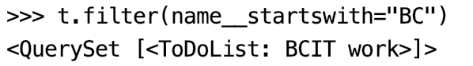

Exercise 4 (2 marks)

Show the errand entry that has your name in it. Use the __contains filter. Show your filter here.

|  |
| --- |
| p.filter(text__contains='V') |

Show a screenshot of the filter query and output when executed in the shell here:

|  |
| --- |
|  |

### Deleting Objects with the ORM

Example 7: Deleting Objects

From the shell, to delete objects, you can first query the specific item to be deleted to verify that it exists:

>>> **i.filter(id=1)**

<QuerySet [<Item: Buy grapefruit.>]>

Then, assign the object to a session variable:

>>> **itemToDelete = i.filter(id=1)**

Then call delete:

>>> **itemToDelete.delete()**

(1, {'pages.Item': 1})

After, verify that the item was deleted from the list:

>>> **i.all()**

<QuerySet [<Item: Do laundry.>, <Item: Study for COMP 4949>, <Item: Study for COMP4948.>, <Item: Make sure Pat gets rest.>]>

### Creating Objects with the ORM

Example 8: Creating Objects with the ORM

This example shows how to create a third ToDoList object.

This instruction creates a list called ‘Graduation preparation’.

>>> **t3 = ToDoList(name='Graduation preparation')**

This instruction commits the changes to the database.

>>> **t3.save()**

This instruction queries the ToDoList to ensure the new list named ‘Graduation preparation’ is present.

>>> **t.all()**

<QuerySet [<ToDoList: Errands>, <ToDoList: BCIT work>, <ToDoList: Graduation preparation>]>

Exercise 5 (4 marks)

Show the commands that are needed to create an Item references the ‘Graduation preparation’ list with a foreign key.

|  |
| --- |
| >>> newItem = Item(id=6, text='Rent robe', complete=0, todolist_id=3)  >>> newItem.save() |

Perform a query of all items. Show a screenshot of the object creation instruction and also query the table after to ensure the object was saved to the Item table. Include the output from these statements in your screenshot. Show your screenshot here:

|  |
| --- |
|  |

### Updating Objects with the ORM

Example 9: Updating Objects with the ORM

To update objects, retrieve the unique object. Then re-assign one of the object’s properties and save the changes. The last statement in this script shows the id of the object. (There probably is a better way)

|  |
| --- |
| from pages.models import Item, ToDoList  t = ToDoList.objects  t.all()  t.all().values_list('id', flat=True) |

The output shows the items in the list.



For this example, “Graduation preparation” will be updated to “Grad prep”. This command gets the object by id and verifies that it is the correct list:

|  |
| --- |
| gradList = t.get(id=3)  print(gradList.name) |

These commands assign a new name to the ToDoList object. Then the changes are saved and verified:

|  |
| --- |
| gradList.name = 'Grad prep'  gradList.save()  print(t.all()) |

### Joins

Example 10: Performing Joins in Django on a Key Value

This example shows how to perform a query which joins content from both the pages_todolist table and the pages_item table.

Note this method requires that the join be performed from the child table ***pages_item*** since each item object has a foreign key to the parent table ***pages_todolist***. This parent on the other hand has no reference the child (see Figure 1).

Figure 1: Parent table “pages_todolist” and Child table “pages_item” with foreign keys to parent.

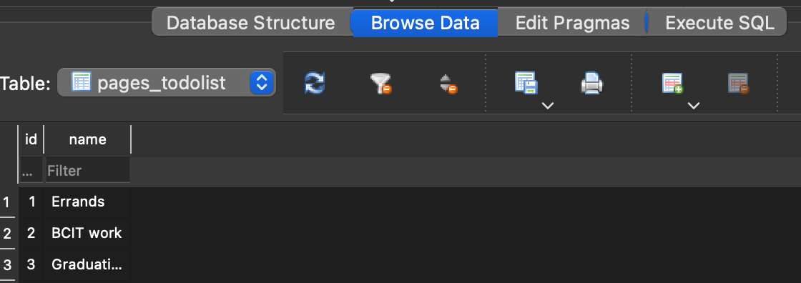

To implement a join query in Django, a filter can be created from the pages_item table which is referenced by Item objects. Running this code will retrieve data from both tables where **pages_todolist.id** =1.

|  |
| --- |
| from pages.models import ToDoList, Item  items = Item.objects  errands = items.filter(todolist_id=1)  itemErrandDetail = errands.select_related('todolist') |

Unfortunately, the print statement does not show all of the data.



However, you can display the SQL code that is generated by the query above by printing the query property:

print(itemErrandDetail.query)

The output confirms that the query does retrieve all related information from the **pages_item** and **pages_todolist** tables.

|  |
| --- |
| SELECT "pages_item"."id", "pages_item"."todolist_id",  "pages_item"."text", "pages_item"."complete",  "pages_todolist"."id", "pages_todolist"."name"  FROM "pages_item" INNER JOIN "pages_todolist"  ON ("pages_item"."todolist_id" = "pages_todolist"."id")  WHERE "pages_item"."todolist_id" = 1 |

Running this in DB Browser for SQLite shows the Item detail joined with the Errand detail.

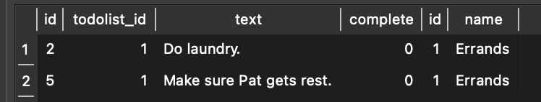

You actually can show detail for the errand table with the following statements. For this case, the first Item object in the list is used to reference the list that corresponds to its foreign key.

|  |
| --- |
| print("*** to do list name and id.")  print(itemErrandDetail[0].todolist.name)  print(itemErrandDetail[0].todolist.id) |

The output displayed shows the todo list and id:

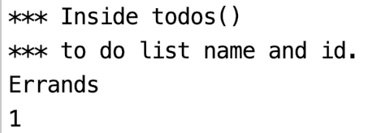

Example 11: Joining on Key Matches

This snippet uses the select_related() function to combine values for all related rows in both the pages_item and pages_todolist tables:

|  |
| --- |
| items = Item.objects  itemErrandDetail = items.select_related('todolist')  print(itemErrandDetail) |

The output that is presented in the console is lacking.

<QuerySet [<Item: Do laundry.>, <Item: Study for COMP 4949>, <Item: Study for COMP4948.>, <Item: Make sure Pat gets rest.>]>

However, to view the full SQL script run this command:

|  |
| --- |
| print(itemErrandDetail.query) |

The query property shows the SQL needed to perform this join for combining all related rows from both tables.

|  |
| --- |
| SELECT "pages_item"."id", "pages_item"."todolist_id",  "pages_item"."text", "pages_item"."complete", "pages_todolist"."id",  "pages_todolist"."name"  FROM "pages_item" INNER JOIN "pages_todolist"  ON ("pages_item"."todolist_id" = "pages_todolist"."id") |

The output when running the SQL in DB Browser for SQLite shows all related item and ToDoList data where there is a match.

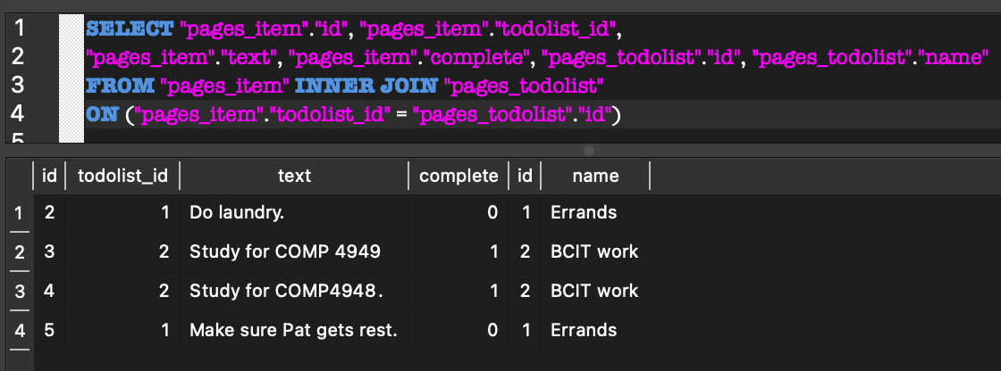

## Accessing Database Content in the Application

Example 12: Accessing Database Content form the Django Application

This example starts with Example 2 to show how to access data within the Django application. After following the steps you will be able to view the data in the database by navigating to the <http://localhost:8000/todos>

Figure 2: Output after completing Example 12

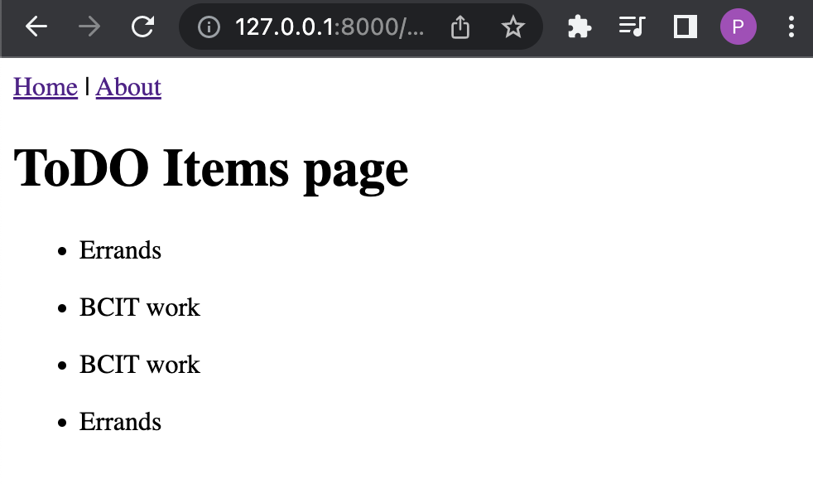

Starting with the solution for lesson week 8 (Django intro), add the following imports to **helloworld/pages/views.py**

|  |
| --- |
| from pages.models import Item, ToDoList |

After, add this todos view to **helloworld/pages/views.py.** This code performs an inner join on the pages_item and pages_todolist tables.

|  |
| --- |
| def todos(request):  print("*** Inside todos()")  items = Item.objects  itemErrandDetail = items.select_related('todolist')  print(itemErrandDetail[0].todolist.name)  return render(request, 'ToDoItems.html',  {'ToDoItemDetail': itemErrandDetail}) |

Note that the view is referring to a template called **ToDoItems.html** but the file does not yet exist. To correct this, add the **ToDoItems.html** file to the **pages/templates** folder.

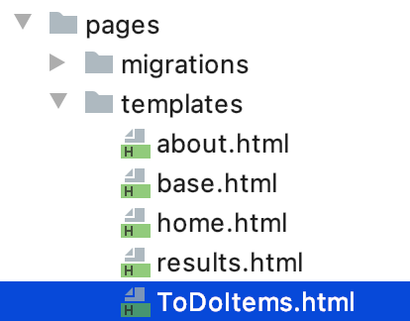

This code will iterate through the itemErrandDetail collection to display the errand name.

|  |
| --- |
| {% extends "base.html" %}  {% block content %}  <h1>ToDO Items page</h1>  {% for todo in ToDoItemDetail %}  <ul>  <li>{{todo.todolist.name}}</li>  </ul>  {% endfor %}  {% endblock content %} |

Next, to tell the router where to find the todos view, add the following highlighted code to **helloworld/pages/urls.py**

|  |
| --- |
| # pages/urls.py  from django.urls import path  from .views import homePageView, aboutPageView, results, homePost, todos  urlpatterns = [  path('', homePageView, name='home'),  path('about/', aboutPageView, name='about'),  path('homePost/', homePost, name='homePost'),  path('results/<int:choice>/<str:gmat>/', results, name='results'),  path('results/<int:choice>/<str:gmat>/', results, name='results'),  path('todos', todos, name='todos')  ] |

You can test your application by running the server and navigating to <http://localhost:8000/todos>

The output should match the output shown in Figure 2.

Exercise 6 (2 marks)

Figure out how to modify pages/templates/base.html to add a link that allows you to navigate to the todos view. If successful, a Todos link will appear on every page. Clicking the link will allow you to view the todos view.



Show your code changes to **base.html** here:

|  |
| --- |
| <!-- templates/base.html --> <a href="{% url 'home' %}">Home</a> | <a href="{% url 'todos' %}">Todos</a> | <a href="{% url 'about' %}">About</a> | <a href="{% url 'victor' %}">Victor</a>  {% block content %} {% endblock content %} |

Exercise 7 (4 marks)

Modify the content in **ToDoItems.html** to show all of the cells of the join. When viewing the todos view you will see the output but with your name in it.



Here is a code hint to get started.

|  |
| --- |
| {% extends "base.html" %}  {% block content %}  <h1>ToDO Items page</h1>  <table>  <!-- table headers -->  <tr>  <th>List Name</th>  <!-- empty column for spacing-->  <th>&nbsp;</th>  <th>List ID</th>  </tr>  {% for todo in ToDoItemDetail %}  <!-- rows of data -->  <tr>  <!-- cells -->  <td>{{todo.todolist.name}}</td>  <!-- empty column for spacing-->  <td>&nbsp;</td>  <td>{{todo.todolist.id}}</td>  </tr>  {% endfor %}  </table>  {% endblock content %} |

Show a screenshot of your output with your name in it after making the required changes.

|  |
| --- |
|  |

Show your code for **ToDoItems.html** as text here:

|  |
| --- |
| {% extends "base.html" %} {% block content %} <h1>ToDO Items page</h1>  <table>  <!-- table headers -->  <tr>  <th>List Name</th>  <!-- empty column for spacing-->  <th>&nbsp;</th>  <th>List ID</th>  <th>&nbsp;</th>  <th>Task</th>  <th>&nbsp;</th>  <th>Item ID</th>   </tr> {% for todo in ToDoItemDetail %}  <!-- rows of data -->  <tr>  <!-- cells -->  <td>{{todo.todolist.name}}</td>  <!-- empty column for spacing-->  <td>&nbsp;</td>  <td>{{todo.todolist.id}}</td>  <td>&nbsp;</td>  <td>{{todo.text}}</td>  <td>&nbsp;</td>  <td>{{todo.id}}</td>   </tr> {% endfor %} </table> {% endblock content %} |

## Using the Admin Panel

Like most major web frameworks, Python provides a pre-built admin area and scaffolding for managing site users.

Example 13: Accessing the Admin Area

This example walks through steps to create a super user that can manage site users. First, exist the shell program by entering **quit()** at the shell prompt.

Then, at the terminal prompt of the virtual environment enter the following command:

**python manage.py createsuperuser**

Next, create a user but please use your first name for exercises that follow. When prompted provide a user name, email and password.

username: yourname

email: yourname@gmail.com

password: password (Django will tell you this password is week but you can force Django to accept it)

After successfully creating a user, you will notice that the user will be visible from the auth_user table in SQLite.

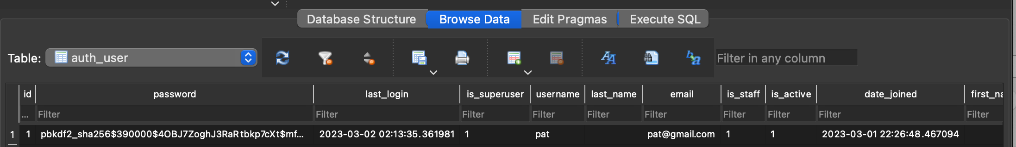

Next, navigate to the prebuilt navigation area at <http://127.0.0.1:8000/admin/login/>

Entering the user name and password at this location will allow you to login to the admin area.

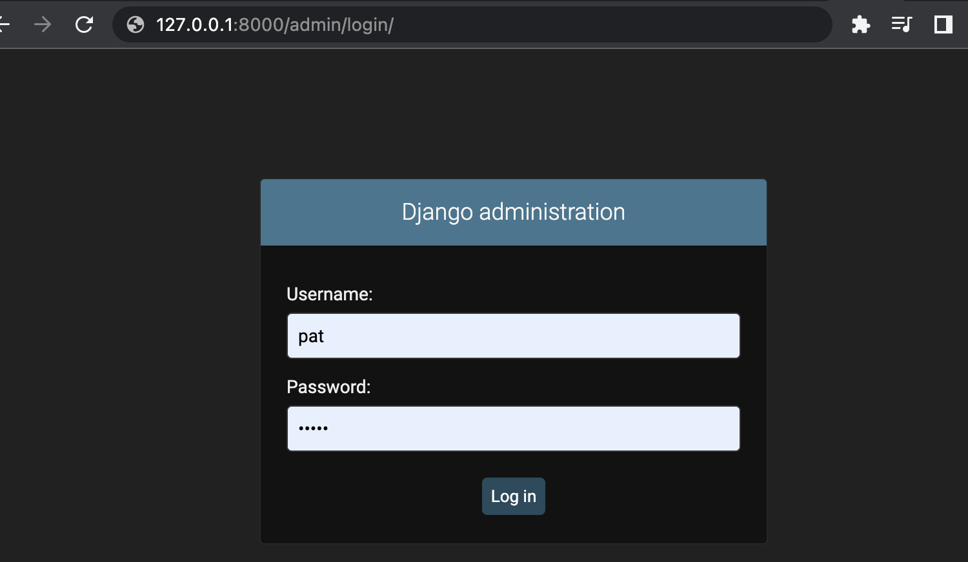

After logged in you will be able to see the admin area.



### Viewing Users From the Admin Panel

This section will show how to enable viewing of database content from the Admin area.

Clicking on the Users link will show your user as shown in Figure 3.

Figure 3: Displaying User from Admin Panel



Exercise 8 (3 marks)

Create an account with your name on it. Show a screenshot of your admin panel with your first name appearing in the user area:

|  |
| --- |
|  |

## Viewing Database Content from the Admin Panel

It is possible to show other database content in the area that is restricted for Admin users.

To view other tables in the Admin Panel, add the following code to Admin.py within the templates folder:

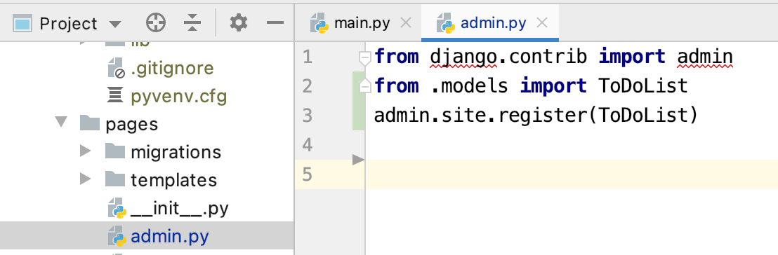

|  |
| --- |
| from .models import ToDoList  admin.site.register(ToDoList) |

You may have to restart the server with the command **python manage.py runserver**

After, the table will be visible in the admin panel.

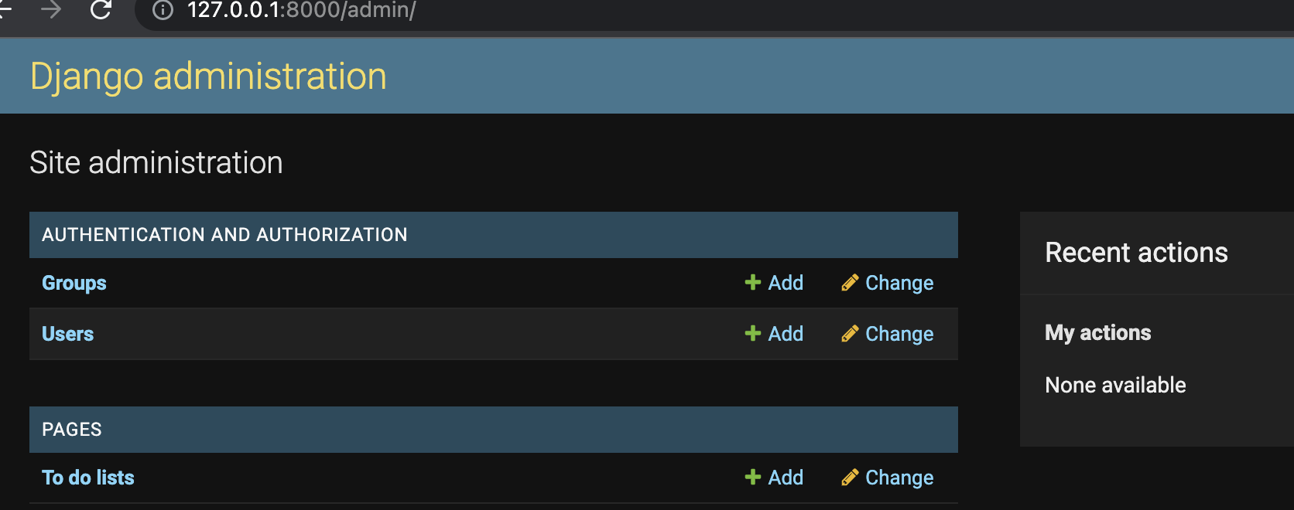

Clicking the “To do lists” link shows the contents.

Figure 4: Displaying the ToDoList objects

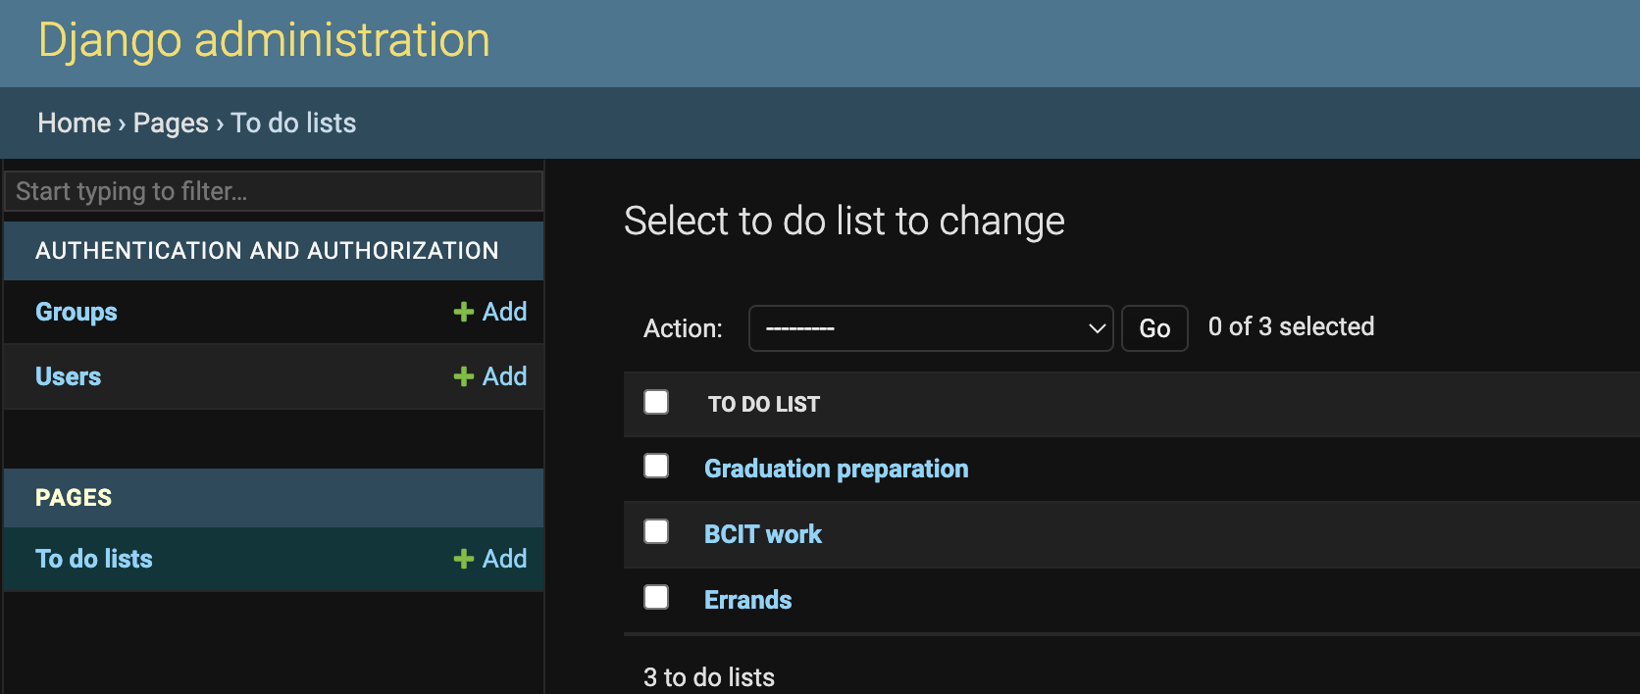

Clicking on one of the lists displays additional operations that are available from the admin panel.

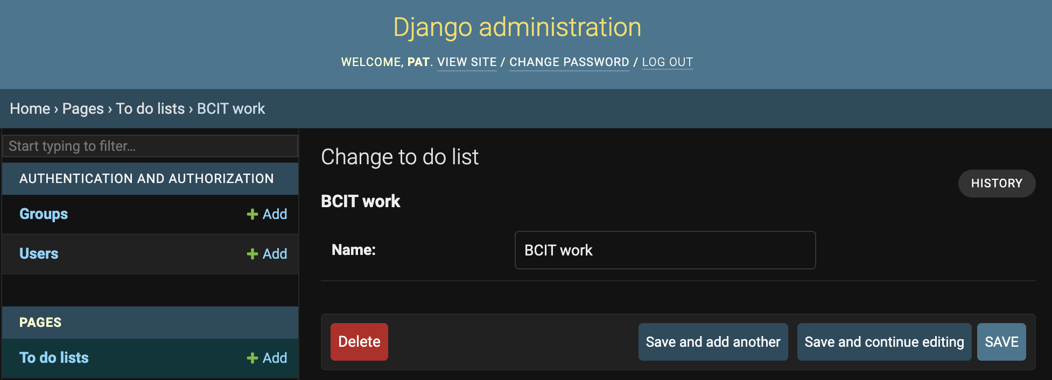

Exercise 9 (3 marks)

Add a reference to the Item table in your application so it can be accessed from the Admin panel. Then click onto the Item table link.



Show the list of items that appears in the admin panel but also show your name in the output. Show your screenshot here:

|  |
| --- |
|  |